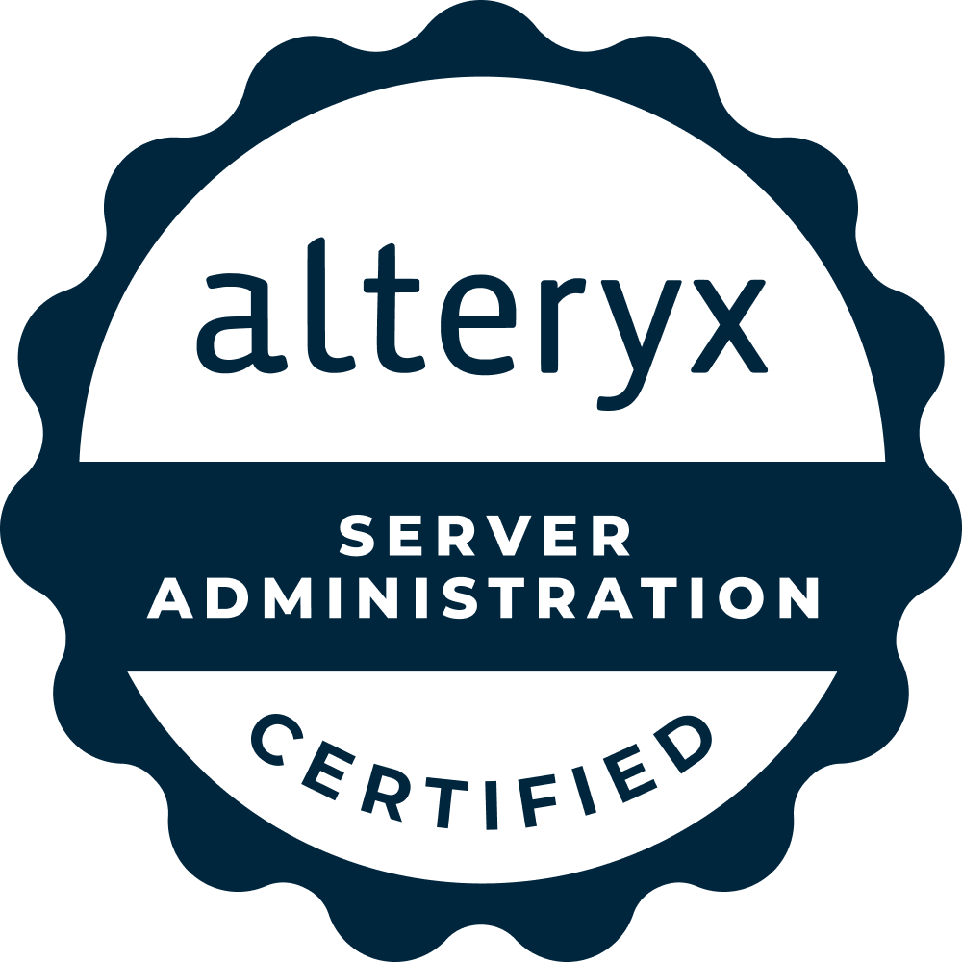

Naga Sai Anvesh Kumar Ganta Anvesh.gantaa@gmail.com 945 527 1686
www.linkedin.com/in/anveshkumarganta

PROFESSIONAL SUMMARY:
- Experienced as ETL Developer with Certified ‘Alteryx platform and Data Analytics’ Professional with a great expertise in Business Intelligence, working as Alteryx consultant with specialization in Data preparation and analysing data to extract meaningful information for business-driven decisions with the help of Dashboards
- I’m certified professional holding these below certifications.
Certified in Alteryx Designer
Certified in Alteryx Advanced
Certified in Alteryx Server Administration
PGP Certified in Data Analytics
- Core experience in developing data analytics products, which includes requirement gathering, analysis, design, data transformation and extensive Bl tools Experience in Enterprise Environment and BI Admin
- Led ETL processes to extract, transform, and load data from multiple sources, ensuring smooth integration into enterprise systems while maintaining data accuracy and consistency throughout the transformation process.
- Translate business logic from various systems, such as Microsoft Excel, on-premise SQL servers, and cloud (Microsoft Azure) SQL Database into Alteryx in a quick and accurate manner.
- Proficient in creating and managing the site's users and groups, created projects to organize content on the site, and assign permissions to allow users (groups)to access the content
- Extracting data from multiple data sources like SQL, SAP, Amazon S3, Azure and transforming into a required format.
- Designed and implemented ETL workflows for complex data transformations, ensuring seamless data integration across various platforms and delivering high-quality datasets for reporting and analytics.
- Proficient in Installing, Configuring and Administration of Bl tools and server performance tuning for optimization.
- Experience in Installing, configuring and administration, upgrading the Alteryx Server in single server installation and distributed installation environments (multi node Cluster setup and design)
- Managing the Bl users and group's security configuration and Integration with active directory.
- Developed and executed data validation routines within ETL pipelines, ensuring data integrity and compliance with business rules and regulatory requirements during data transformation and integration processes.
- Used Informatica power center for ETL extraction, transformations and loading data from source systems to target tables.
- Working in a cloud environment to reduce that time to insight as for making changes, the product hierarchy needs to update daily on live data.
- Worked on google cloud environment(GCP) to extract the live data and automate on a frequency basis.
- Automated ETL processes to streamline the transformation and integration of structured and unstructured data into centralized databases, improving efficiency and ensuring data accuracy.
- Installing the Google Cloud Platform connector in Alteryx Designer.

- Authenticate your GCP account within Alteryx by providing the necessary credentials and Connect to the desired GCP services, such as BigQuery or Cloud Storage, within your Alteryx workflows.
- Did Data Quality testing and Data Profiling validation, Data accuracy, Data completeness, Data stewardship, Regulatory compliance processes in Enterprise level Data Warehouse as well as in Small systems.
- Optimization of Alteryx workflows to take advantage of GCP's scalability and advanced computing capabilities
- Updating the target tables in SQL and Pulling the data from SQL with increment logic on a daily basis
- Extensive working knowledge on Alteryx, Tableau Desktop, Tableau Server, Tableau Online, Tableau Prep, Power BI, Python.
- Used various sources to pull data into PowerBi for dashboard building to help end users.
- Developed reports to visually explore data and create interactive reports using PowerBi and Tableau.
- Build, develop and maintain data models, reporting systems, data automation systems, dashboards and performance metrics using Tableau, Power BI and SQL Queries, VBA Macros and Power Query DAX Codes that support key business decisions.
- Utilized analytical applications like R and Python to identify trends and relationships between different pieces of data, draw appropriate conclusions, and translate analytical findings into risk management and marketing strategies that drive value.
- Experience using python libraries for machine learning like pandas, numpy, matplotlib to Load, summarize, visualizing the dataset and evaluating some machine learning algorithms to predict the risk.
- Break down complex business problems into easy procedures by writing queries, dynamic-queries, sub-queries, views and complex joins for generating complex stored procedures, triggers in SAS & R to extract data to analytical tools, visualization software.
- Led the complete life cycle of visual analytical applications using Tableau, Qliksense & data management using SAS and R, from the development of mock-ups and storyboards to the complete production-ready application.
- Scheduled data refresh on Tableau Server for daily, weekly and monthly increments
- Highly experienced in Analysis, Design, Development, Implementation, Maintenance, Deployment and Integration of application in Agile environment.
- Have great exposure in Banking, Insurance, Health care and Finance Domains.
- Ability to collaborate with peers in both, business, and technical areas, to deliver the optimal business process solutions, in line with corporate priorities.
- Working closely with business strategy teams, especially for global sales initiatives, to implement new Qlik Sense applications and ensure they meet strategic goals
- Thorough understanding of Python basic concepts like Lists, Strings, Indexing
- Design and develop ETL workflows and datasets in Alteryx to be used by the BI Reporting tools.
- Providing the user access in Alteryx server for publishing and executing the workflows.
- Managing the licence access for the authorised users in Alteryx administration
- Handling the Alteryx designer and server installations in Desktop and On-prem.
- Supported technical team members in development of automated processes for data extraction and analysis.
- Implementing Agile methodologies and using tools like QSDA Pro to improve the performance of Qlik Sense applications
- Designed and built dashboards for use in monitoring performance metrics while maintaining existing dashboards for accuracy and efficiency and incorporating changes using Tableau.
- Excellent Communication and presentation skills.
- Experience in debugging and troubleshooting the errors using backtracking method.
- Highly motivated and dedicated with strong Analytical & Logical Development skills.
- Experience and desire to work in Global offshore/onshore model.
- Strong interpersonal skills and committed to integrity and best business practices. Analytical mindset with a talent for tailoring data-based solutions for changing business needs.

TECHNICAL SKILLS:

Operating Systems | Windows
Skills | Alteryx Designer, Alteryx Server, ETL, Tableau, PowerBI, Excel,  Data Analytics, R, Python, Machine Learning
Visualization & Scripting  Tools | Alteryx, Tableau, Power BI, Python
Databases | SQL, SAP BW, S3, Databricks, Snowflake
Tools & utilities | JIRA
Methodologies | Agile
Domains | Insurance, Banking, Health Care and Finance.
EDUCATION DETAILS:
  - Bachelor of Technology | Mechanical Engineering, Rise Gandhi Group of Institution, India, 2015.
EDUCATION DETAILS:
  - Certified in Alteryx Designer.
  - Certified in Alteryx Advanced.
  - PGP Certified in Data Analytics.
PROFESSIONAL EXPERIENCE:

Client: Genesis 10|Optum | Jan 2025 - Till Date|MI,USA ROLE: Sr. Alteryx Developer
Project Description:
Helping clients By automating data extraction, transformation, and loading, clients can streamline workflows, improve data accuracy, and ensure timely access to critical insights, allowing for more efficient decision-making and resource management.
- Design and develop ETL workflows and datasets in Alteryx to be used by the BI Reporting tools.
- Providing the user access in Alteryx server for publishing and executing the workflows.
- Managing the licence access for the authorised users in Alteryx administration
- Handling the Alteryx designer and server installations in Desktop and On-prem.
- Supported technical team members in development of automated process
- Running campaigns to the customers based on the historic data
- Setup and configuration of Alteryx server in various environments and use alteryx gallery to configure the server according to best practices
- Extracting data from PDF using Alteryx and formatting in to required format and scheduling for Automation
- I monitor Tableau server performance and application status schedule
- Extracting data from Snowflake database and transform as per the requirement and loading to the target tables with data checks

Client: Cognizant|Raymond James| Jan 2024 – Dec 2024|Florida,USA ROLE: Sr. Alteryx Developer
Project Description:
Helping clients with end-to-end automation by transforming data from multiple sources using ETL processes, significantly reducing manual efforts and monthly user dependency. By automating data extraction, transformation, and loading, clients can streamline workflows, improve data accuracy, and ensure timely access to critical insights, allowing for more efficient decision-making and resource management.
Responsibilities:

  - Design and develop ETL workflows and datasets in Alteryx to be used by the BI Reporting tools.
  - Providing the user access in Alteryx server for publishing and executing the workflows.
  - Led ETL processes using Alteryx for data integration and transformation, ensuring seamless extraction, transformation, and loading of data from multiple sources into centralized systems for comprehensive analysis and reporting
  - Managing the licence access for the authorised users in Alteryx administration
  - Handling the Alteryx designer and server installations in Desktop and On-prem.
  - Supported technical team members in development of automated processes for data extraction and analysis.
  - Validate the ETL load process to make sure the target tables are populated according the data mapping from Source (ODS) to target validation Field to Field verification.
  - Designed and built dashboards for use in monitoring performance metrics while maintaining existing dashboards for accuracy and efficiency and incorporating changes using Tableau.
  - Utilized Tableau Desktop to create multiple dashboards that appropriately told stories of business status and success, strengths visual representations of profitability, products, and customer
  - Backup strategies for Database Recovery, backing up databases, backing up data files, log files, verifying the integrity of backup files and performing the restoration of data.
  - Good exposure on Case level auditing and Field Level auditing events.
  - Developed and implemented data validation workflows in Alteryx, ensuring the accuracy and integrity of datasets during migration and integration processes, particularly in financial systems and large-scale data transformations.
  - Creating users, groups, projects, sites on Alteryx server and Involving in workflow deployments during the monthly production releases and post release support
  - Collaborated with data engineering teams to design and execute Alteryx-based ETL solutions for handling complex data transformations, ensuring that datasets were accurately integrated into Oracle and AWS cloud environments.
  - Worked on tuning the SQL queries to bring down run time by working on improving efficiency.
  - Responsible for Design, Development and testing of the database and developed storage procedures, views and triggers.
  - Automated ETL workflows using Alteryx to streamline data extraction from legacy systems, transforming and loading the data into Oracle Financials and other enterprise platforms, enhancing data accessibility and reducing manual processing time.
  - Configuring the BI Servers for alerts which is for system health and low disk space and monitoring the disk usage in the administrative views and Configuring failover and high availability gateways.
  - Worked on Joins and Blending to access data from Multiple Data Sets
  - Publishing customized interactive reports and dashboards
  - Creating the Email alerts for all the jobs
  - Created Process flows, properties based on requirements.

Client: Amazon | May 2023 – Jan 2024 |Seattle,USA ROLE: Sr. Alteryx Developer
Project Description:
Helping users with end to end automation by transforming the data from multiple sources. ETL processes. Designed and implemented ETL workflows to automate data extraction, transformation, and loading, allowing business users to seamlessly access insights on the performance of their products compared to competitors. Business people use the results to identify the performance of their own products with competitors to improve the business on a frequency basis and also reducing the manual efforts and dependency that is doing by the user every month

Responsibilities:
  - Worked on Data-Integration, Data Mapping, Data Profiling and Data Warehouse access using SQL, ETL process.
  - Responsible for data transformation and integration between cloud-based systems and on-premise environments, utilizing Alteryx to manage the seamless flow and transformation of structured and unstructured data.
  - Working as administrator performing responsibilities like Installing, Configuring and Administration of Data Visualization Product Suites like Alteryx, Tableau (ETL).
  - Server architecture and solutions to troubleshoot performance, scheduling and server related issues.
  - Built complex Alteryx workflows to support data integration projects, transforming raw datasets into actionable insights, ensuring consistency with business rules, and adhering to federal data standards.
  - Managed end-to-end ETL processes, overseeing the extraction, transformation, and integration of data from disparate systems, and implementing rigorous data validation protocols to ensure consistency and accuracy.
  - Advanced performance tuning skills, ability to automate tasks using Alteryx scheduler
  - Worked on AWS Data Pipeline to configure data loads from s3 to Redshift
  - Using AWS redshift extracted data from various data sources
  - Setup and configuration of Alteryx server in various environments and use alteryx gallery to configure the server according to best practices
  - Extracting data from PDF using Alteryx and formatting in to required format and scheduling for Automation
  - I monitor Tableau server performance and application status schedules and maintenance 70 users globally
  - Optimized ETL workflows for the integration of various data sources, applying advanced data transformation techniques to ensure seamless compatibility with downstream applications while performing comprehensive data validation checks.
  - Worked on SQL*Loader to load data from flat files obtained from various facilities every day
  - Involved in publishing of various kinds of live, interactive data visualizations, dashboards, reports and workbooks from Tableau Desktop to Tableau servers.
  - Create Alteryx workflows for such scenarios where data is not readily available
  - Gathered and loaded data into tableau from various sources (Oracle, SAP)
  - Generating Adhoc reports for the business needs
  - Implemented best practices in ETL design to support efficient data transformation and integration while ensuring high standards of data validation and accuracy for critical business processes.
  - Developed ETL pipelines that incorporated automated data validation steps, ensuring that transformed and integrated datasets were error-free and ready for use in financial reporting and business analysis.
  - Provide data analytic services to help clients solve business problems, drive value and insight from information, focusing on the consumption of data.
  - Backup, data recovery and service restoration management & Incident, problem and service outage management
  - Creating users, groups, projects, sites on Alteryx server and Involving in workflow deployments during the monthly production releases and post release support
  - Worked on tuning the SQL queries to bring down run time by working on improving efficiency.
  - Responsible for Design, Development and testing of the database and developed storage procedures, views and triggers.
  - Configuring the BI Servers for alerts which is for system health and low disk space and monitoring the disk usage in the administrative views and Configuring failover and high availability gateways.
  - providing access to the users in the Alteryx gallery for accessing the workflows to use it.
  - Monitoring Alteryx schedules on a daily basis and providing a report to the users post completion.

  - Help clients realize the full potential of data through effective reporting and analysis and key metrics.

Ernst & Young Global Delivery Services | Nov 2021 – Mar 2023 | Hyd, India ROLE: Sr. Alteryx Developer/Administrator
Project Description:
Provide data analytics services to help clients solve business problems, drive value and insight from information, with a focus on the consumption and transformation of data. Develop and automate ETL processes to transform manual, time-consuming data handling tasks into efficient, scalable workflows, reducing user dependency and saving clients time and effort. Extract, transform, and load data from various sources into centralized systems, enabling clients to leverage the full potential of their data through streamlined reporting, analysis, and actionable insights. Support clients in tracking key metrics and generating valuable insights by ensuring data quality, consistency, and availability through effective ETL solutions.
Responsibilities:
  - Alteryx workflows & ETL Processes, Set up Alteryx server & managed server configurations
  - Alteryx advanced analytics Macros, Predictive Analytics, Spatial Data, Connectors, Tableau Hyper Extracts, In-Database tools, Transform & Join.
  - Developed reusable ETL components to automate common data integration tasks, reducing manual intervention and increasing overall system reliability and accuracy during data transformation.
  - Led the ETL development process, leveraging Alteryx to ensure that data transformation and validation routines were efficient and aligned with project requirements for migrating and integrating financial data.
  - Defining and recommending metrics, measures, reporting and solutions for Tableau Visualization.
  - Create Big Data ETL process for visualization process
  - Create alteryx workflows with advanced analytics
  - Validated and transformed large datasets during data migrations using Alteryx, ensuring the integrity and accuracy of financial data during transitions between Oracle Financials and other enterprise systems.
  - Create analytical application in alteryx designer and store on alteryx server for non - technical user
  - Create In-database alteryx workflows and data preparation for visualization in Tableau & Power-BI
  - Extracting the data from multiple sources like SQL, AWS Amazon S3, Databricks, Sap BW, Outlook, Snowflake and preparing it for further analysis.
  - Pulling data from SQL with Increment logic on daily basis, migrated data using python framework.
  - Strong in writing Complex SQL queries in RDBMS to Analyze large amount of data
  - Updating the target tables in the database where Tableau can use the finalised data to refresh the dashboards.
  - Worked on Data-Integration, Data Mapping, Data Profiling and Data Warehouse access using SQL, ETL process.
  - Worked on SQL*Loader to load data from flat files obtained from various facilities every day
  - Involved in publishing of various kinds of live, interactive data visualizations, dashboards, reports and workbooks from Tableau Desktop to Tableau servers.
  - Handled Alteryx and Tableau admin activities granting access, managing extracts and Installations.
  - Created Tableau dashboards as part of the Analytics/Reporting factory
  - Created action filters, parameters and calculated fields for preparing dashboards and worksheets in Tableau.
  - Worked on Joins and Blending to access data from Multiple Data Sets
  - Publishing customized interactive reports and dashboards
  - Creating the Email alerts for all the jobs
  - Created Process flows, properties based on requirements.

  - Worked with project managers, developers, quality assurance and customers to resolve technical issues.
Environment: Alteryx, Alteryx Gallery, Tableau, BI, Excel, R, Python, SQL, SharePoint, Jira.

KPMG Global delivery services | Mar 2020 – Nov 2021 | Bng, India ROLE: ETL Developer, Data Analytics
Project Description:
Goal of the project is to provision schedules by reviewing, preparing, and consolidating provision schedules, Assess and research difficult tax issues to identify solutions. On-boarding the new clients in to Tax Engine by cleaning the data into required format.
Responsibilities:
  - Interacting with multiple business teams to collect the requirements and arrive at data and reporting specs through User Stories
  - Developed reusable ETL components to automate common data integration tasks, reducing manual intervention and increasing overall system reliability and accuracy during data transformation.
  - Set up Alteryx server & managed server configurations
  - Create SQL connections for pulling & loading the data
  - Wrote and maintained complex ETL code to transform and load unstructured and structured data, ensuring data quality and consistency throughout the pipeline and across all integrated systems.
  - Develop new and modify existing SQL code based on the requirements to generate data reports
  - Use joins and sub queries / nested queries in SQL
  - Coordinating with data team to source data; Model the data in case of data not existing, as needed
  - Create Alteryx workflows for such scenarios where data is not readily available
  - Gathered and loaded data into tableau from various sources (Oracle, SAP)
  - Generating Adhoc reports for the business needs
  - Unit testing and data validation
  - Publishing the dashboard and walkthrough with business users
  - Used various ETL tools to extract data into Tableau Desktop and data wrangling using Alteryx in data preparation phase. Performing end to end Data validation
  - Extensively communicated with business analysts and explained the scenarios from business perspective rather than from a developer perspective.
  - Develop and update semi-automated of data preparation.
  - Create technical documentation of logic and processes.
  - Maintaining and updating the previous workflows.
Environment: Alteryx, Alteryx Gallery, Excel, SQL, Tableau, SharePoint, Jira, Python.

Team Computers Pvt ltd | Mar 2018 – Mar 2020 | Mumbai, India ROLE: Data Analyst (Healthcare)
Project Description:
Helped client with Analysis with their patient data by transforming from multiple sources to identify the trends and patterns. Developed and maintained the Alteyrx automation to improve their accessibility and identify areas to improve. Business people use the results of customer feedback to identify the performance of their own service with competitors to improve the business on a monthly refresh
Responsibilities:
  - Interacting with business team to collect the requirements and arrive at data requirements
  - Coordinating with data team to source data; Model the data in case of data not existing, as needed.
  - Handled datasets and proficient in writing efficient queries.

  - Managed the database for all portfolios including data extraction, conversion, cleaning and merging.
  - Interacting and updating the customers daily about the open tasks and in progress assignments.
  - Develop huge number of ETL processes for error handling, data manipulation, data preparation using Alteryx using SQL server management console/ database
  - Utilizing SAP business objects in designing and building the reporting environment
  - Create Alteryx workflows for such scenarios where data is not readily available
  - Gathered and loaded data into tableau from various sources
  - Generating Business Dashboards with drill downs and slice & Dice of Data
  - Unit testing and data validation
  - Publishing the dashboard and walkthrough with business users
  - Provide data analytic services to help clients solve business problems, drive value and insight from information, focusing on the consumption of data.
  - Help clients realize the full potential of data through effective reporting and analysis and key metrics.

Indigen Technologies Pvt ltd | Sep 2015 – Sep 2017 | Hyd, India ROLE: Data Analyst
Project Description:
Using Alteryx platform automated the manual and repeatable process by extracting the data files from the outlook and transformed in to required standard format for creating the dashboards for business needs.
Responsibilities:
  - Interacting and updating the customers daily about the open tasks and in progress assignments.
  - Extracting the data from different sources like flat Files, SQL and loading in Database
  - All the business logics will be applied with Alteryx workflows and final Reporting layer will be created.
  - Have worked on almost all data processing tools in Alteryx
  - Scheduling and monitored the daily jobs in Alteryx
  - Created macros and application whenever required to reduce the time to create workflow.
  - Involved in design and development of Data Model, Data Preparation. Understanding the technical requirements from business requirements
  - Had Troubleshoot technical problems and conducted analyses for efficient program/application solutions which support client business processes and functional requirements.
  - Involved in testing and troubleshooting the issues of applications.

